Nicholas Skinner

CS 475

Spring 2019

**Project #7A OpenCL / OpenGL Particle System**

**Video Link:**

[**https://media.oregonstate.edu/media/t/0_jilpwth1**](https://media.oregonstate.edu/media/t/0_jilpwth1)

**Project in action:**

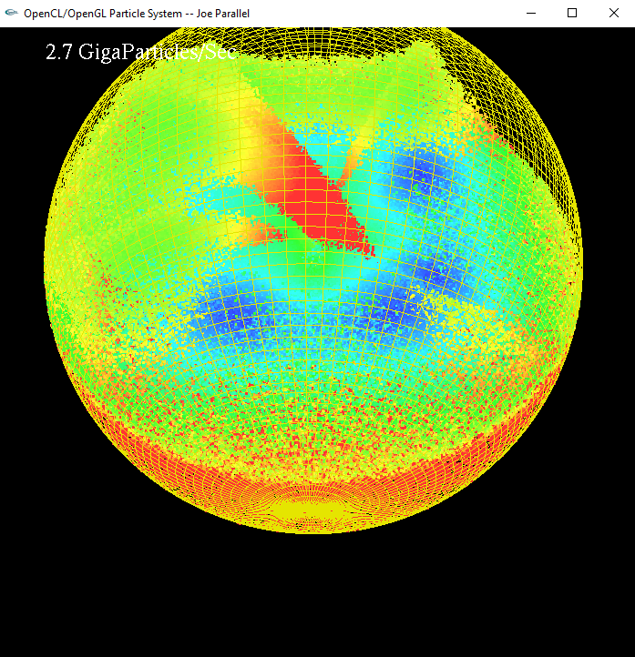

**What machine did you run this on?**

My local machine, my graphics card, and processor are as follows:

**Graphics Card:** NVIDIA GeForce RTX 2080

**Processor:** Intel(R) Core(TM) i9-9900K CPU @ 3.60GHz, 3600 Mhz, 8 Core(s), 16 Logical Processor(s)

**Dynamic thing with particles colors:**

I colored the particles based on their velocity, slower ones appear blue, faster ones appear red

**Table:**

|  |  |  |  |  |  |  |  |  |  |  |
| --- | --- | --- | --- | --- | --- | --- | --- | --- | --- | --- |
| ArrSize*1024 | 64 | 128 | 256 | 516 | 1024 | 2048 | 4096 | 8192 | 16384 | 32768 |
| Run | 0.2 | 0.6 | 0.9 | 1.3 | 2.1 | 3 | 3.7 | 4.3 | 4.5 | 4.4 |

**Graph:**

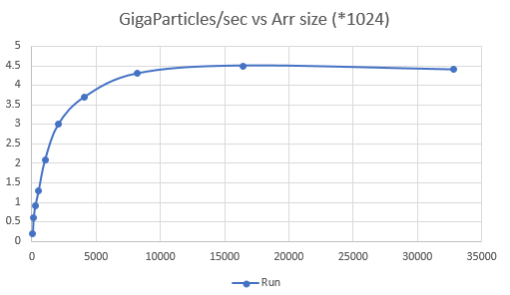

**Patterns? Why do these appear?**

This appears to share a trait with many of our previous assignments, where there appears to be some overhead time to start up the gpu. Each increment gets a huge performance increase up to (8192*1024), where it appears to stagnate in performance. In my case, this performance increase seems to taper off at ~4.4 GigaParticles/sec.

I presume this is due to the overhead that I had mentioned, if there is not enough work to do, the GPU can’t stand up to the cost of setup, so performance will lapse.

**What does this imply for the proper use of GPU computing?**

This implies that before sending things to calculate on the gpu, you should ensure that the payoff will be worth it. If it is a small sample size, you may be able to work it out locally much faster than sending it out to the gpu. However, as you scale up the number of actions that need to be taken, the GPU becomes more valuable for its performance increase.